

WaterUI Online Water Account Setup Instructions
Manage your water account and order irrigation water with WaterUI

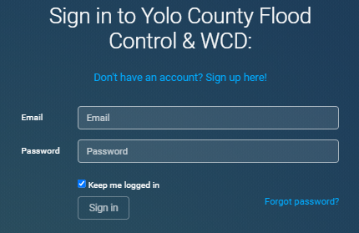



Go to ycfc.waterui.com and click the blue link
Don’t have an account? Sign up here!





Input your email address and a new password
for your WaterUI account. Confirm your new
password and then click Sign up.





Input Account ID and Access Code found on your water statement and click Submit.
Questions? Call or email us at:
530-662-0265 or info@ycfcwcd.org

